EXPERIMENT-5

1: Roots of a Quadratic Equation

Aim
To write a C program to find the roots of a quadratic equation ax² + bx + c = 0.

Formula
D = b² − 4ac
If D > 0, roots are real and distinct.
If D = 0, roots are real and equal.
If D < 0, roots are imaginary/complex

Algorithm
- Start the program.
- Declare the variables a, b, c, D, root1 and root2.
- Ask the user to enter the values of the coefficients a, b and c.
- Read the values of a, b and c.
- Check whether the value of a is equal to zero.
- If a = 0, display "It is not a quadratic equation" and terminate the program.
- If a ≠ 0, calculate the discriminant using: D = b² − 4ac
- Check whether D > 0.
- If D > 0, calculate the two roots using:
root1 = (-b + √D) / (2a)
root2 = (-b - √D) / (2a)
- Display the two real and distinct roots.
- If D = 0, calculate the root using: root = -b / (2a)
- Display that both roots are equal.
- If D < 0, calculate the real part using: Real part = -b / (2a)
- Calculate the imaginary part using: Imaginary part = √(-D) / (2a)
- Display the two complex roots in the form: Real part + Imaginary part i and Real part − Imaginary part i.
- Stop

C Program
#include <stdio.h>
#include <math.h>

int main()
{
float a, b, c, D, root1, root2;
float realPart, imagPart;

printf("Enter a, b and c: ");
scanf("%f %f %f", &a, &b, &c);

if (a == 0)
{
printf("It is not a quadratic equation.\n");
}
else
{
D = b * b - 4 * a * c;

if (D > 0)
{
root1 = (-b + sqrt(D)) / (2 * a);
root2 = (-b - sqrt(D)) / (2 * a);

printf("Two real and distinct roots:\n");
printf("Root 1 = %.2f\n", root1);
printf("Root 2 = %.2f\n", root2);
}
else if (D == 0)
{
root1 = -b / (2 * a);

printf("Two real and equal roots:\n");
printf("Root 1 = Root 2 = %.2f\n", root1);
}
else
{
realPart = -b / (2 * a);
imagPart = sqrt(-D) / (2 * a);

printf("Two complex roots:\n");
printf("Root 1 = %.2f + %.2fi\n",
realPart, imagPart);
printf("Root 2 = %.2f - %.2fi\n",
realPart, imagPart);
}
}

return 0;

Test Cases
a | b | c | d | Result
1 | -5 | 6 | 1 | 3, 2
1 | 2 | 1 | 0 | -1, -1
1 | 2 | 5 | -16 | Complex roots

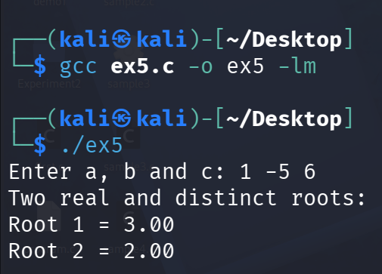

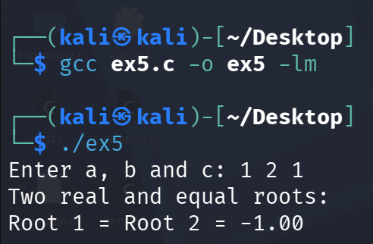

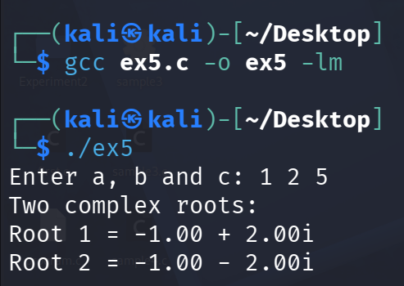

2: Menu-Driven Income Tax Calculator

Aim
To write a menu-driven C program to calculate income tax under the old and new tax regimes

Algorithm
- Start the program.
- Declare variables for the taxpayer's name, age, gross income, deductions, taxable income, tax, rebate, cess and final tax.
- Ask the user to enter the taxpayer's name.
- Read the taxpayer's name.
- Ask the user to enter the taxpayer's age.
- Read the age.
- Ask the user to enter the gross income.
- Read the gross income.
- Display the following menu:
Old Tax Regime
New Tax Regime
Exit
- Ask the user to enter their choice.
- If the user selects Old Tax Regime, proceed with the old-regime calculation.
- Ask the user to enter the standard deduction, savings deduction, pension deduction, medical deduction, home-loan interest, savings-account interest and senior-citizen interest, wherever applicable.
- Apply the maximum deduction limits specified in the question.
- Add all the allowed deductions to calculate: Total deduction = Sum of all deductions
- Calculate taxable income using: Taxable income = Gross income − Total deduction
- If taxable income is less than zero, set taxable income equal to zero.
- Determine the taxpayer's age category:
- Non-senior citizen: below 60 years
- Senior citizen: 60 to below 80 years
- Super senior citizen: 80 years or above
- Apply the appropriate old-regime tax slabs according to the taxpayer's age.
- Calculate the income tax before rebate.
- Check whether taxable income is less than or equal to ₹5,00,000.
- If it is, calculate the rebate as the minimum of ₹12,500 and the calculated tax.
- If taxable income is above ₹5,00,000, take the rebate as zero.
- If the user selects New Tax Regime, take: Taxable income = Gross income
- Apply the new-regime tax slabs to calculate the income tax.
- Check whether taxable income is less than or equal to ₹12,00,000.
- If it is, calculate the rebate as the minimum of ₹60,000 and the calculated tax.
- If taxable income is above ₹12,00,000, take the rebate as zero.
- Calculate tax after rebate using: Tax after rebate = Tax before rebate − Rebate
- Calculate health and education cess using: Cess = 4% × Tax after rebate
- Calculate the final tax payable using: Final tax = Tax after rebate + Cess
- Display the taxpayer's name, age, gross income, taxable income, tax before rebate, rebate, tax after rebate, cess and final tax payable.
- Return to the menu so that another calculation can be performed.
- If the user selects Exit, terminate the program.
- If an invalid choice is entered, display "Invalid choice" and ask the user to enter the choice again.
- Stop

C program
#include <stdio.h>
#include <math.h>

double oldTax(double income, int age)
{
double tax = 0;

if (age < 60)
{
if (income > 250000)
tax += (fmin(income, 500000) - 250000) * 0.05;

if (income > 500000)
tax += (fmin(income, 1000000) - 500000) * 0.20;

if (income > 1000000)
tax += (income - 1000000) * 0.30;
}
else if (age < 80)
{
if (income > 300000)
tax += (fmin(income, 500000) - 300000) * 0.05;

if (income > 500000)
tax += (fmin(income, 1000000) - 500000) * 0.20;

if (income > 1000000)
tax += (income - 1000000) * 0.30;
}
else
{
if (income > 500000)
tax += (fmin(income, 1000000) - 500000) * 0.20;

if (income > 1000000)
tax += (income - 1000000) * 0.30;
}

return tax;
}

double newTax(double income)
{
double tax = 0;

if (income > 400000)
tax += (fmin(income, 800000) - 400000) * 0.05;

if (income > 800000)
tax += (fmin(income, 1200000) - 800000) * 0.10;

if (income > 1200000)
tax += (fmin(income, 1600000) - 1200000) * 0.15;

if (income > 1600000)
tax += (fmin(income, 2000000) - 1600000) * 0.20;

if (income > 2000000)
tax += (fmin(income, 2400000) - 2000000) * 0.25;

if (income > 2400000)
tax += (income - 2400000) * 0.30;

return tax;
}

int main()
{
char name[100];
int age, choice;

double grossIncome;
double taxableIncome;
double totalDeduction;
double tax, rebate;
double cess, finalTax;

printf("Enter name: ");
scanf(" %99[^\n]", name);

printf("Enter age: ");
scanf("%d", &age);

printf("Enter gross income: ");
scanf("%lf", &grossIncome);

do
{
printf("\n1. Old Tax Regime");
printf("\n2. New Tax Regime");
printf("\n3. Exit");
printf("\nEnter choice: ");
scanf("%d", &choice);

if (choice == 1)
{
double standard, savings, pension;
double medical, homeLoan;
double savingsInterest, seniorInterest;

printf("Standard deduction: ");
scanf("%lf", &standard);

printf("Savings deduction: ");
scanf("%lf", &savings);

printf("Pension deduction: ");
scanf("%lf", &pension);

printf("Medical deduction: ");
scanf("%lf", &medical);

printf("Home loan interest: ");
scanf("%lf", &homeLoan);

printf("Savings account interest: ");
scanf("%lf", &savingsInterest);

if (age >= 60)
{
printf("Senior citizen interest: ");
scanf("%lf", &seniorInterest);
}
else
{
seniorInterest = 0;
}

standard = fmin(standard, 50000);
savings = fmin(savings, 150000);
pension = fmin(pension, 50000);
medical = fmin(medical, 25000);
homeLoan = fmin(homeLoan, 200000);
savingsInterest = fmin(savingsInterest, 10000);
seniorInterest = fmin(seniorInterest, 50000);

totalDeduction = standard + savings + pension +
medical + homeLoan +
savingsInterest + seniorInterest;

taxableIncome = grossIncome - totalDeduction;

if (taxableIncome < 0)
taxableIncome = 0;

tax = oldTax(taxableIncome, age);

if (taxableIncome <= 500000)
rebate = fmin(12500, tax);
else
rebate = 0;
}
else if (choice == 2)
{
taxableIncome = grossIncome;

tax = newTax(taxableIncome);

if (taxableIncome <= 1200000)
rebate = fmin(60000, tax);
else
rebate = 0;
}
else if (choice == 3)
{
printf("Program terminated.\n");
break;
}
else
{
printf("Invalid choice.\n");
continue;
}

tax = tax - rebate;

cess = 0.04 * tax;

finalTax = tax + cess;

printf("\n----- TAX DETAILS -----\n");
printf("Name: %s\n", name);
printf("Age: %d\n", age);
printf("Gross Income: %.2lf\n", grossIncome);
printf("Taxable Income: %.2lf\n", taxableIncome);
printf("Rebate: %.2lf\n", rebate);
printf("Tax After Rebate: %.2lf\n", tax);
printf("Cess: %.2lf\n", cess);
printf("Final Tax Payable: %.2lf\n", finalTax);

} while (choice != 3);

return 0;
}

Test Cases
Regime | Age | Gross income | Taxable income | Result
Old | 19 | Rs 9,00,000 | Rs 6,55,000 | Rs 45,000
New | 19 | Rs 11,00,000 | Rs 11,00,000 | Rs 0
New | 19 | Rs 15,00,000 | Rs 15,00,000 | Rs 1,09,200

